1) Create and Test a Kubernetes Pod with an EmptyDir Volume

What is emptyDir (quick idea)
- It’s a temporary storage inside a Pod
- Created when Pod starts
- Deleted when Pod is removed
- Shared between containers in the same Pod
Think: “temporary folder for containers to share data”
Step 1: Create YAML file
Create a file:
vi emptydir-pod.yaml
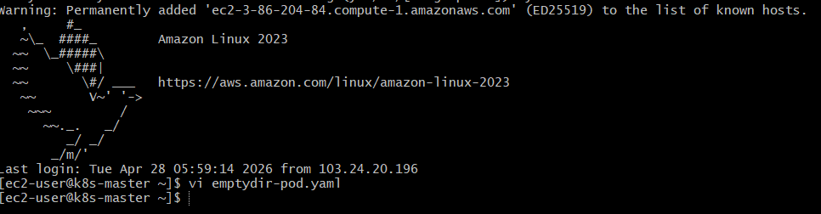
Paste this:
apiVersion: v1
kind: Pod
metadata:
name: emptydir-pod
spec:
containers:
- name: container1
image: busybox
command: ["/bin/sh", "-c", "echo Hello from container1 > /data/file.txt; sleep 3600"]
volumeMounts:
- name: shared-volume
mountPath: /data
- name: container2
image: busybox
command: ["/bin/sh", "-c", "sleep 3600"]
volumeMounts:
- name: shared-volume
mountPath: /data
volumes:
- name: shared-volume
emptyDir: {}
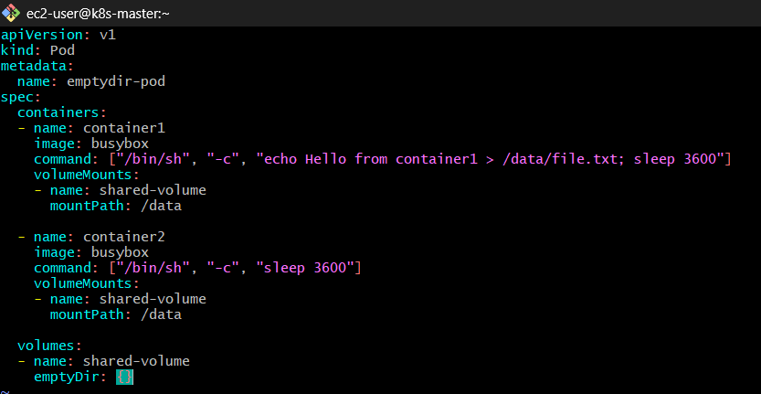

Step 2: Apply the Pod
kubectl apply -f emptydir-pod.yaml
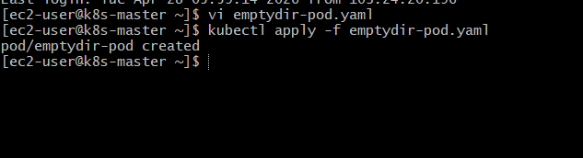
Check:
kubectl get pods
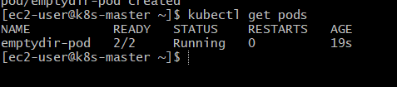
Wait until status = Running

Step 3: Verify Data Sharing
Now we test if both containers share the same storage.
Enter container2:
kubectl exec -it emptydir-pod -c container2 – sh
Inside container:
cat /data/file.txt
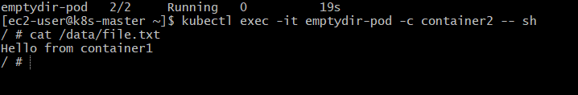
Output should be:
Hello from container1
This proves:
- container1 wrote data
- container2 read it
- Both using same emptyDir

Step 4: Create New File from Container2
Inside container2:
echo "Hello from container2" > /data/file2.txt
Exit:
exit
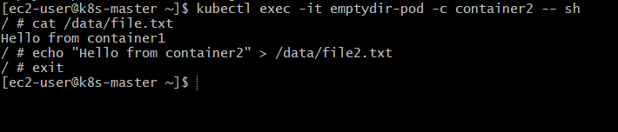
Now check from container1:
kubectl exec -it emptydir-pod -c container1 -- sh
cat /data/file2.txt
Output:
Hello from container2
✅ Bidirectional sharing works
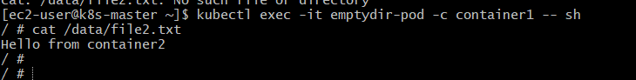
Step 5: Important Behavior (Interview Point)
Delete Pod:
kubectl delete pod emptydir-pod
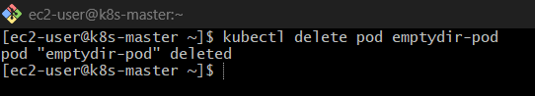
Recreate:
kubectl apply -f emptydir-pod.yaml
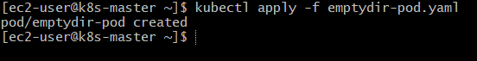
Now check file again:
kubectl exec -it emptydir-pod -c container2 -- sh
ls /data
Files will be gone
Because:
- emptyDir is ephemeral (temporary) \
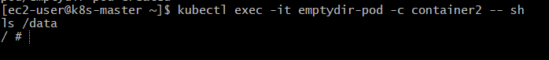
Key Concepts (Very Important)
- Lives as long as Pod lives
- Deleted when Pod dies
- Shared across containers
- Stored on: Node disk OR memory (if configured)

💥 Bonus: Memory-based emptyDir (Advanced)
emptyDir:
medium: Memory
Stores data in RAM (faster but volatile)
Real Use Cases
- Sidecar logging
- Data processing pipelines
- Cache sharing
- Temporary file exchange

2) Configure a HostPath Volume in Kubernetes and Validate Data Persistence

What is hostPath (quick clarity)
- Mounts a directory from the Node (EC2 machine) into a Pod
- Data persists even if Pod is deleted
- Tightly coupled to a specific node
Think: “Pod using host machine’s folder directly”

Step 1: Create directory on Node (EC2)
Login to your node (master/worker where Pod will run):
sudo mkdir -p /data/hostpath-demo
sudo chmod 777 /data/hostpath-demo

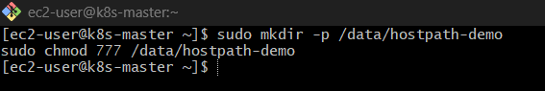
Verify:
ls /data
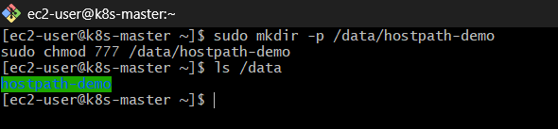

Step 2: Create YAML
vi hostpath-pod.yaml
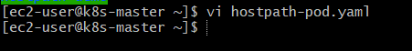
Paste:
apiVersion: v1
kind: Pod
metadata:
name: hostpath-pod
spec:
containers:
- name: container1
image: busybox
command: ["/bin/sh", "-c", "sleep 3600"]
volumeMounts:
- name: host-volume
mountPath: /app
volumes:
- name: host-volume
hostPath:
path: /data/hostpath-demo
type: Directory
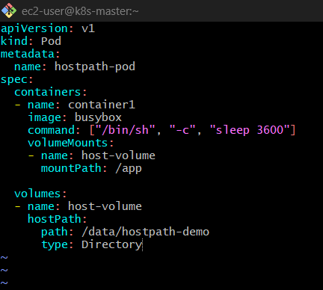

Step 3: Apply Pod
kubectl apply -f hostpath-pod.yaml
kubectl get pods
Wait until Running
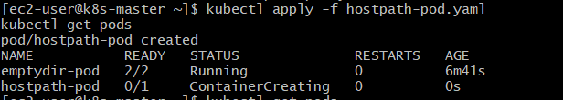
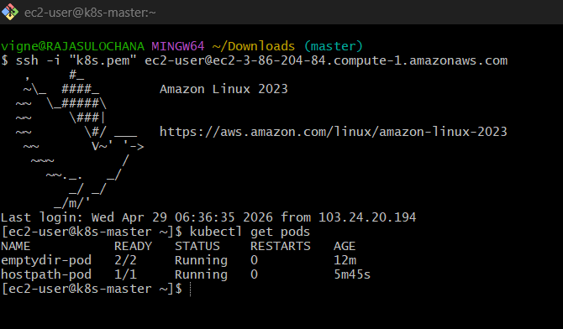

Step 4: Write data inside Pod
Enter container:
kubectl exec -it hostpath-pod -- sh
Inside:
echo "Hello from Pod" > /app/file.txt
cat /app/file.txt
Exit:
exit
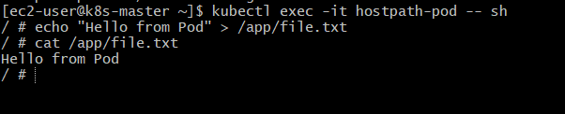
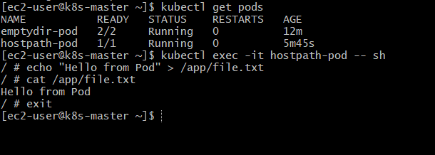

Step 5: Verify on Node (EC2)
Now check directly on EC2:
SSH into worker node
ssh ec2-user@k8s-worker2
cat /data/hostpath-demo/file.txt
Output:
Hello from Pod
This proves:
- Pod wrote data
- Data stored on host machine
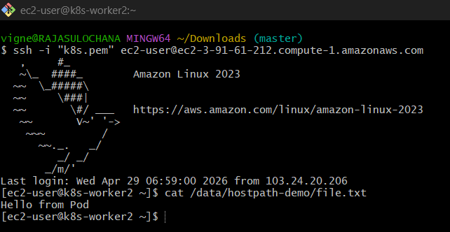

Step 6: Test Persistence
Delete Pod:
kubectl delete pod hostpath-pod
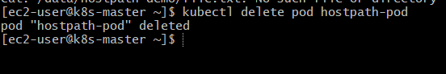
Recreate:
kubectl apply -f hostpath-pod.yaml
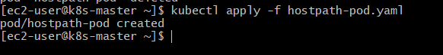
Now check inside Pod again:
kubectl exec -it hostpath-pod -- cat /app/file.txt
Output:
Hello from Pod
✅ Data persists even after Pod deletion
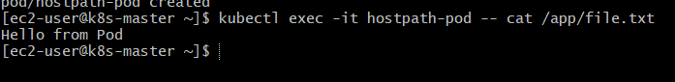

Important Points
❗ 1. Node dependency
- If Pod moves to another node → data lost
- Because path exists only on one node

❗ 2. Security risk
- Pod can access host filesystem
- Can break node if misused

❗ 3. Not recommended for production
Use instead:
- PersistentVolume (PV)
- PersistentVolumeClaim (PVC)

Key Difference (emptyDir vs hostPath)
Feature | emptyDir ❌ |  |  |  | hostPath ✅
Storage | Temporary |  |  |  | Persistent
Lifetime | Pod |  |  |  | Node
Use case | Sharing |  |  |  | Local storage
Safe? | Yes |  |  |  | Risky

Bonus: Auto-create directory
Instead of manual creation:
hostPath:
path: /data/hostpath-demo
type: DirectoryOrCreate
Kubernetes creates it automatically

Real Use Cases
- Node-level logging
- Access Docker socket (/var/run/docker.sock)
- Debugging node issues

3) Deploy an Amazon EBS Volume Using Persistent Volume and Persistent Volume Claim (PVC)

Big Picture (understand this first)
- Amazon EBS → actual disk in AWS
- PersistentVolume (PV) → Kubernetes representation of that disk
- PersistentVolumeClaim (PVC) → request for storage by Pod
Flow:
Pod → PVC → PV → EBS Volume

Prerequisites (important)
Make sure:
- You’re on AWS EC2 cluster
- Nodes have IAM role with EBS permissions
- Kubernetes version supports EBS (awsElasticBlockStore or CSI)

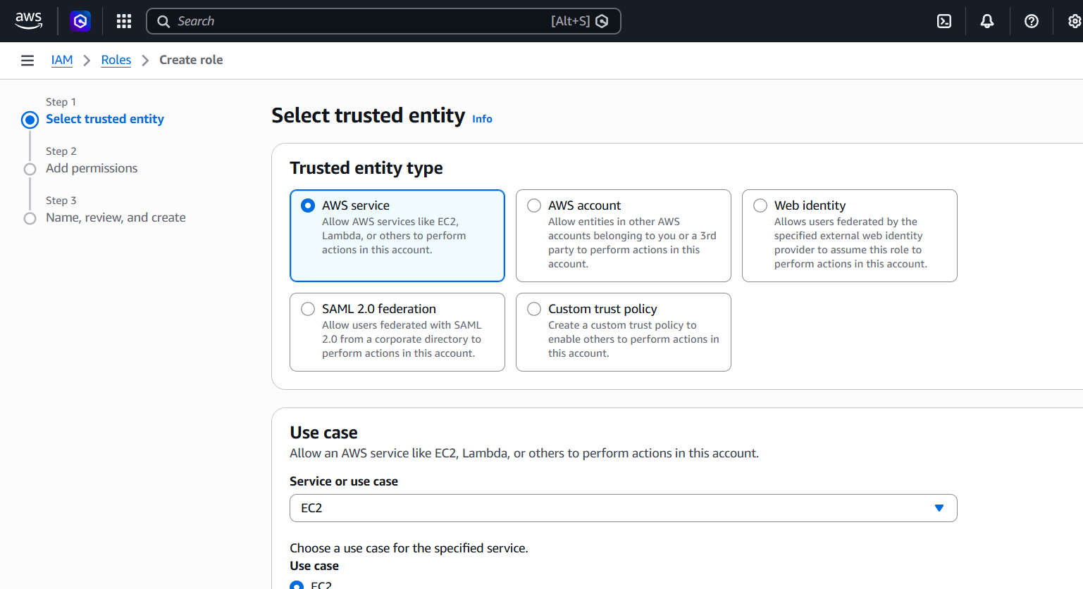
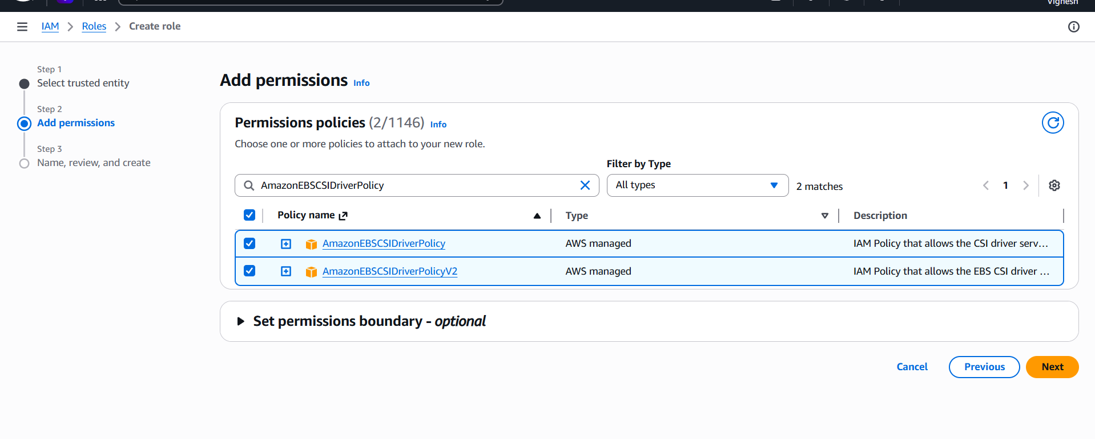

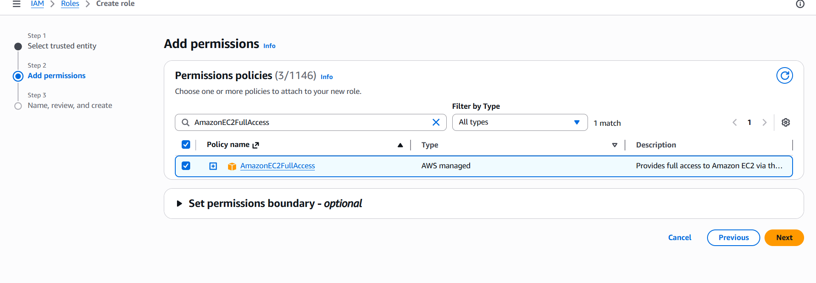

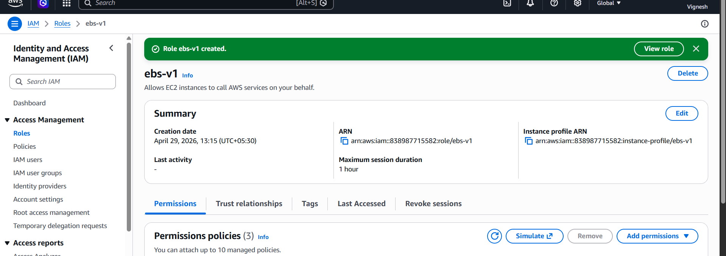
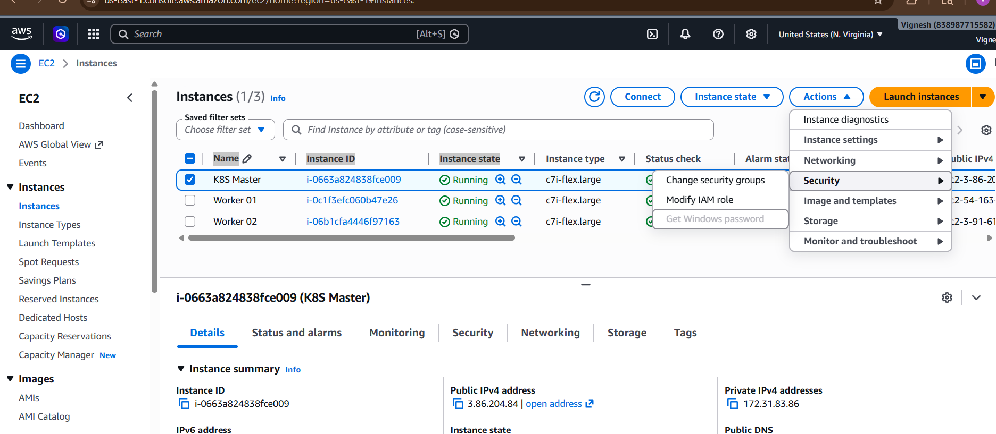

For All 3 Nodes
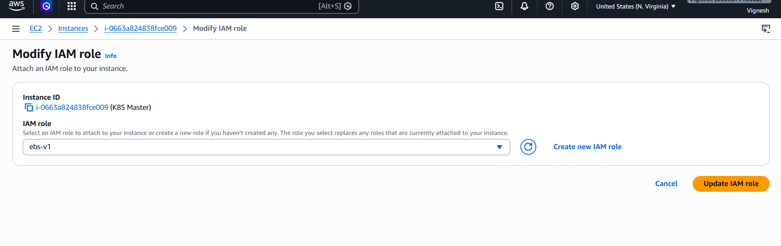
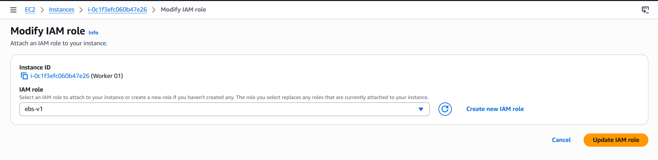

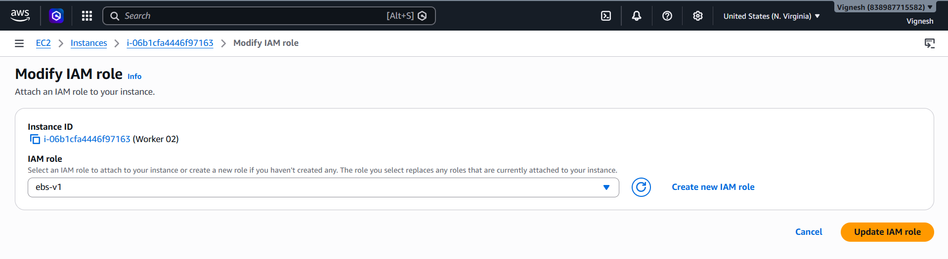

Install git (quick fix)
sudo yum install git -y

Then run again:
kubectl apply -k "github.com/kubernetes-sigs/aws-ebs-csi-driver/deploy/kubernetes/overlays/stable/?ref=v1.27.0"

Verify installation:
kubectl get pods -n kube-system

You should now see:
ebs-csi-controller-xxxxx Running
ebs-csi-node-xxxxx Running

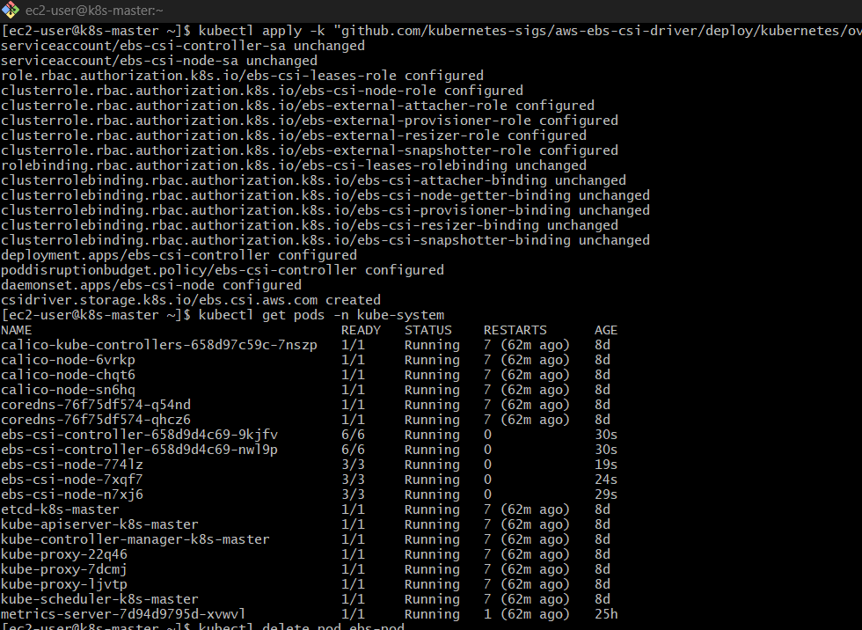

To Check Availability Zones:
kubectl get nodes -L topology.kubernetes.io/zone
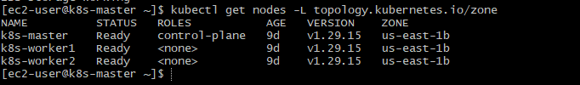

Step 1: Create EBS Volume (AWS)
Go to:
👉 Amazon Web Services Console → EC2 → Volumes
Create:
- Size: 2–5 GB
- Type: gp2 or gp3
- Availability Zone: same as your worker node
👉 Copy Volume ID (e.g., vol-0abcd1234)

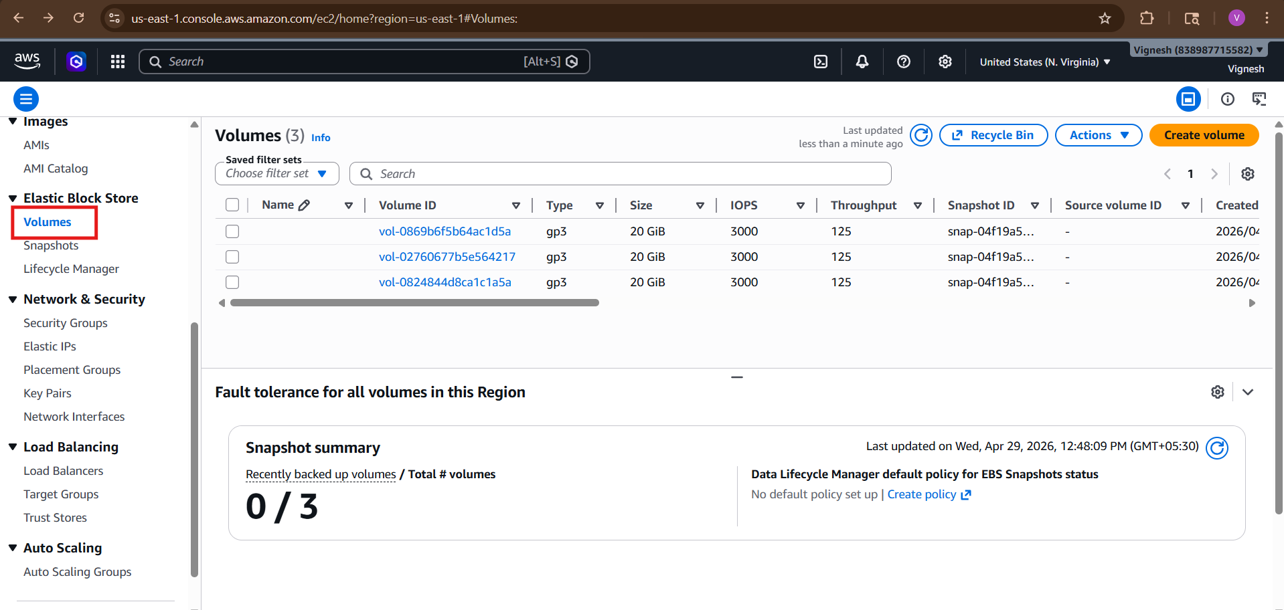
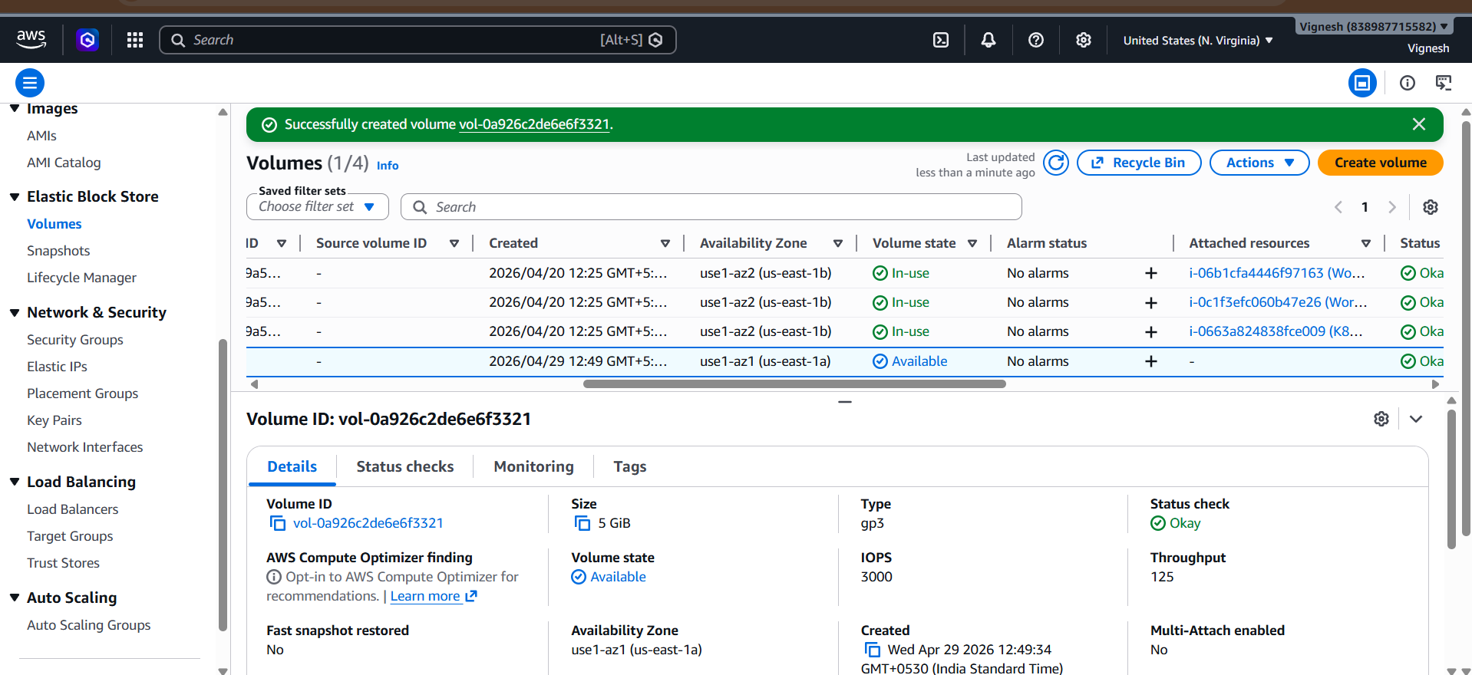

Step 2: Create Persistent Volume (PV)
vi ebs-pv.yaml
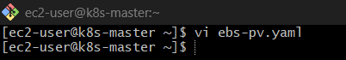
Paste:
apiVersion: v1
kind: PersistentVolume
metadata:
name: ebs-pv
spec:
capacity:
storage: 5Gi
accessModes:
- ReadWriteOnce
awsElasticBlockStore:
volumeID: vol-xxxxxxxx # <-- replace with your EBS volume ID
fsType: ext4
persistentVolumeReclaimPolicy: Retain
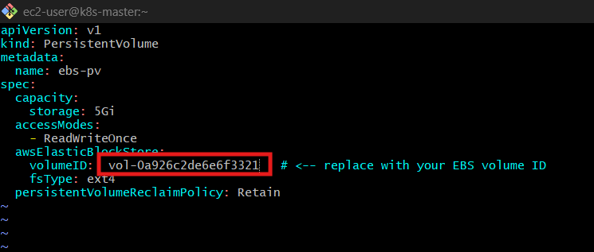
Apply:
kubectl apply -f ebs-pv.yaml
kubectl get pv

Step 3: Create Persistent Volume Claim (PVC)
vi ebs-pvc.yaml
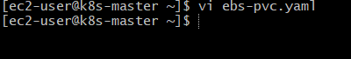
Paste:

apiVersion: v1
kind: PersistentVolumeClaim
metadata:
name: ebs-pvc
spec:
accessModes:
- ReadWriteOnce
resources:
requests:
storage: 5Gi
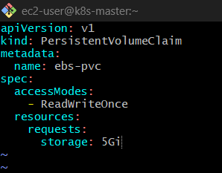
Apply:
kubectl apply -f ebs-pvc.yaml
kubectl get pvc
👉 Status should be:
Bound
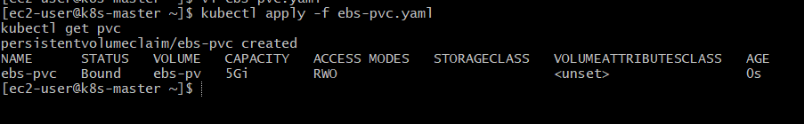

Step 4: Create Pod using PVC
vi ebs-pod.yaml
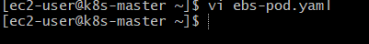
Paste:
apiVersion: v1
kind: Pod
metadata:
name: ebs-pod
spec:
containers:
- name: app
image: busybox
command: ["/bin/sh", "-c", "sleep 3600"]
volumeMounts:
- mountPath: /data
name: ebs-volume
volumes:
- name: ebs-volume
persistentVolumeClaim:
claimName: ebs-pvc
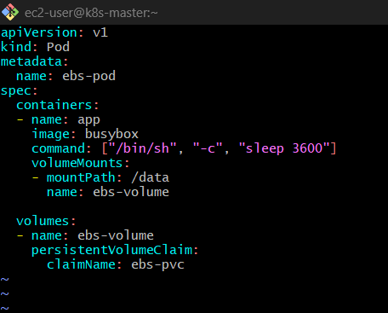
Apply:
kubectl apply -f ebs-pod.yaml
kubectl get pods
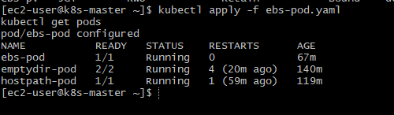

Step 5: Test Storage
Enter Pod:
kubectl exec -it ebs-pod – sh
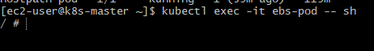
Inside:
echo "EBS storage working" > /data/test.txt
cat /data/test.txt
Exit:
exit
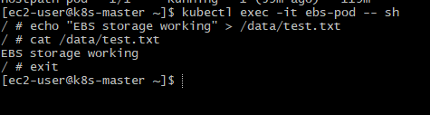

Step 6: Test Persistence
Delete Pod:
kubectl delete pod ebs-pod
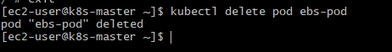
Recreate:
kubectl apply -f ebs-pod.yaml
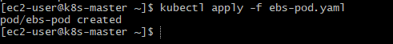
Check again:
kubectl exec ebs-pod -- cat /data/test.txt
👉 Output:
EBS storage working
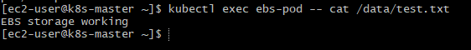
✅ Data persists even after Pod deletion

Important Concepts
🔹 1. AZ Limitation
- EBS works only in same Availability Zone
- Pod must run on node in that AZ

🔹 2. Access Mode
- ReadWriteOnce → only one node can mount
- Most common for EBS

🔹 3. Reclaim Policy
- Retain → data stays even if PVC deleted
- Delete → volume deleted automatically

Bonus (Modern way – Dynamic Provisioning)
Instead of manual PV:
Use StorageClass → auto-creates EBS

Final Comparison
Storage Type |  |  |  | Scope |  |  |  | Persistence
emptyDir |  |  |  | Pod |  |  |  | ❌ No
hostPath |  |  |  | Node |  |  |  | ⚠️ Limited
EBS (PVC) |  |  |  | Cloud |  |  |  | ✅ Yes

You just learned
- Real cloud storage integration
- How Kubernetes manages disks
- Industry-standard storage flow

4) Set Up an Amazon EFS Volume and Attach it to Multiple Pods

What is EFS (quick clarity)
- Network file system (like NFS)
- Works across multiple AZs
- Supports ReadWriteMany (RWX) ✅
Perfect for:
- Shared uploads
- Logs
- Web content

Step 1: Create EFS in AWS
Go to 👉 Amazon Web Services Console → EFS
Create:
- Name: k8s-efs
- VPC: same as your cluster
- Enable mount targets (important)
👉 After creation, copy:
FileSystem ID: fs-xxxxxxx
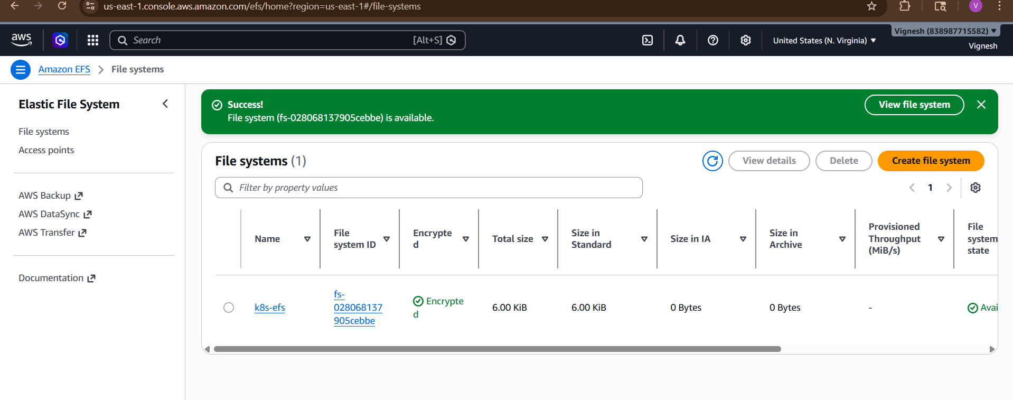

Step 2: Security Group (VERY IMPORTANT)
EFS must allow NFS traffic:
👉 Add rule:
Type: NFS
Port: 2049
Source: your EC2 nodes SG

Step 3: Install EFS CSI Driver
Run:
kubectl apply -k "github.com/kubernetes-sigs/aws-efs-csi-driver/deploy/kubernetes/overlays/stable/?ref=release-1.5"
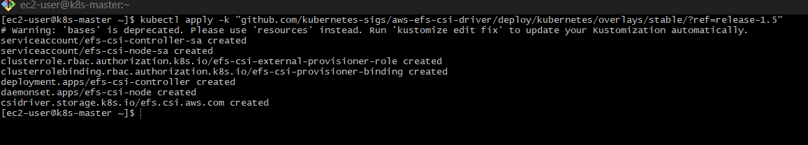

Verify
kubectl get pods -n kube-system | grep efs
👉 Expect:
efs-csi-controller-xxxxx Running
efs-csi-node-xxxxx Running
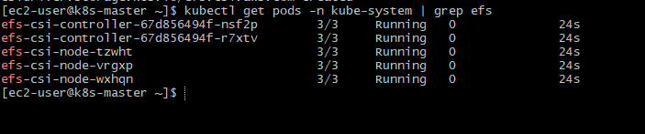

Step 4: Create Persistent Volume (PV)
vi efs-pv.yaml
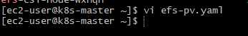
apiVersion: v1
kind: PersistentVolume
metadata:
name: efs-pv
spec:
capacity:
storage: 5Gi
volumeMode: Filesystem
accessModes:
- ReadWriteMany
persistentVolumeReclaimPolicy: Retain
csi:
driver: efs.csi.aws.com
volumeHandle: fs-xxxxxxxx # your EFS ID

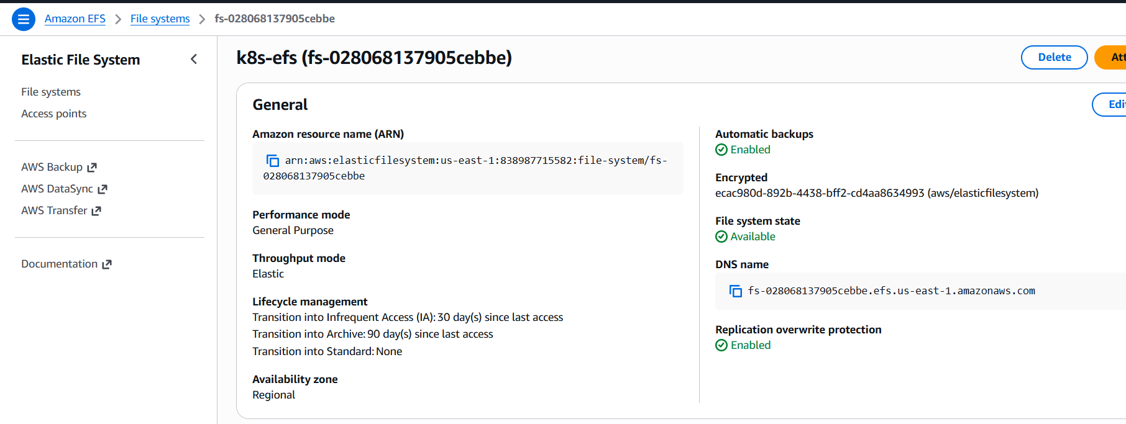

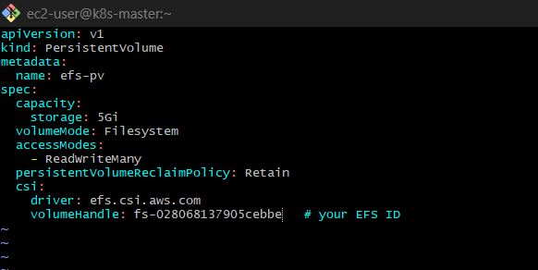

Apply:
kubectl apply -f efs-pv.yaml
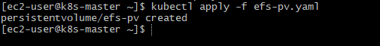

Step 5: Create PVC
vi efs-pvc.yaml
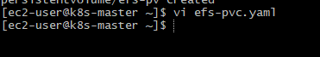

apiVersion: v1
kind: PersistentVolumeClaim
metadata:
name: efs-pvc
spec:
accessModes:
- ReadWriteMany
resources:
requests:
storage: 5Gi

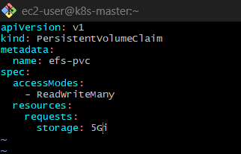

Apply:
kubectl apply -f efs-pvc.yaml
kubectl get pvc
👉 Should be:
Bound ✅

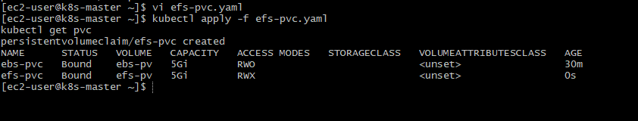

Step 6: Create TWO Pods using same PVC
🔹 Pod 1
Create file:
vi efs-pod1.yaml
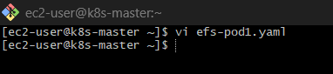
Paste:
apiVersion: v1
kind: Pod
metadata:
name: efs-pod-1
spec:
containers:
- name: app
image: busybox
command: ["/bin/sh", "-c", "sleep 3600"]
volumeMounts:
- mountPath: /data
name: efs-volume
volumes:
- name: efs-volume
persistentVolumeClaim:
claimName: efs-pvc
Save 👉 :wq
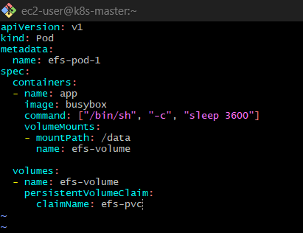

🔹 Pod 2
Create file:
vi efs-pod2.yaml
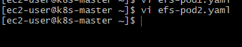
Paste
apiVersion: v1
kind: Pod
metadata:
name: efs-pod-2
spec:
containers:
- name: app
image: busybox
command: ["/bin/sh", "-c", "sleep 3600"]
volumeMounts:
- mountPath: /data
name: efs-volume
volumes:
- name: efs-volume
persistentVolumeClaim:
claimName: efs-pvc
Save 👉 :wq
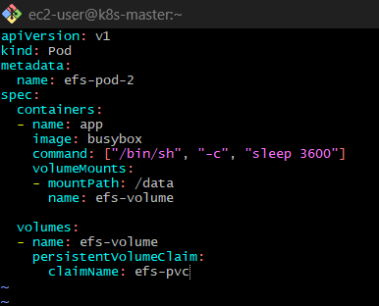

Apply both:
kubectl apply -f efs-pod1.yaml
kubectl apply -f efs-pod2.yaml
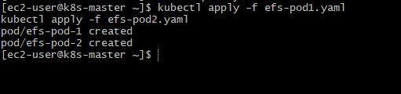

Step 7: Test shared storage
🔹 Write from Pod 1
kubectl exec -it efs-pod-1 – sh
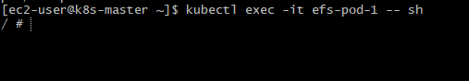
echo "Hello from Pod1" > /data/shared.txt
exit
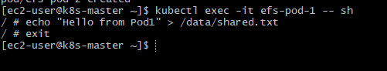

🔹 Read from Pod 2
kubectl exec -it efs-pod-2 -- cat /data/shared.txt
👉 Output:
Hello from Pod1
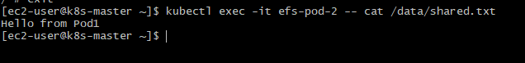
This proves:
- Same storage
- Shared across pods
- Works across nodes

Key Concepts
Feature |  |  |  | EBS |  |  | EFS
Access |  |  |  | RWO |  |  | RWX ✅
Multi-node |  |  |  | ❌ |  |  | ✅
AZ |  |  |  | Single |  |  | Multi-AZ
Use case |  |  |  | DB |  |  | Shared storage

Common Issues
- ❌ Mount timeout → security group issue
- ❌ Pod stuck → CSI driver missing
- ❌ Permission denied → EFS access point config

You just learned
- Shared storage across pods
- RWX volumes
- Network-based storage

5) Implement and Test Liveness and Readiness Probes in a Kubernetes Pod

First: Understand the difference (quick)
Probe | Purpose
Liveness | “Is container alive?” → restart if dead
Readiness | “Can it serve traffic?” → control traffic flow
👉 Think:
- Liveness = doctor 🩺 (restart if sick)
- Readiness = gatekeeper (allow traffic or not)

Step 1: Create Pod with both probes
vi probe-pod.yaml
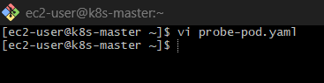
Paste this:
apiVersion: v1
kind: Pod
metadata:
name: probe-pod
spec:
containers:
- name: app
image: busybox
command: ["/bin/sh", "-c", "touch /tmp/healthy; sleep 3600"]
livenessProbe:
exec:
command:
- cat
- /tmp/healthy
initialDelaySeconds: 5
periodSeconds: 5
readinessProbe:
exec:
command:
- cat
- /tmp/ready
initialDelaySeconds: 5
periodSeconds: 5
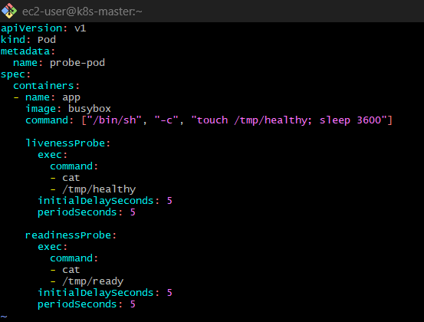
Step 2: Apply Pod
kubectl apply -f probe-pod.yaml
kubectl get pods
👉 You’ll see:
probe-pod 0/1 Running (not ready)
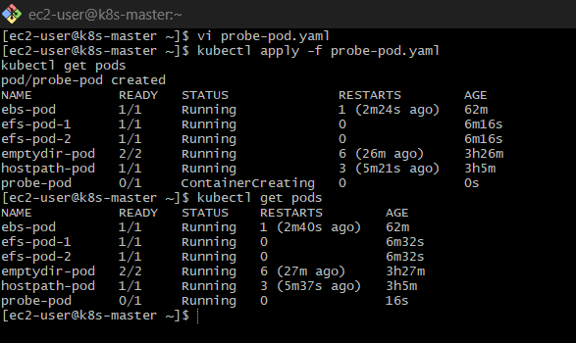

Step 3: Check why not ready
kubectl describe pod probe-pod
👉 You’ll see:
Readiness probe failed
👉 Because /tmp/ready does NOT exist
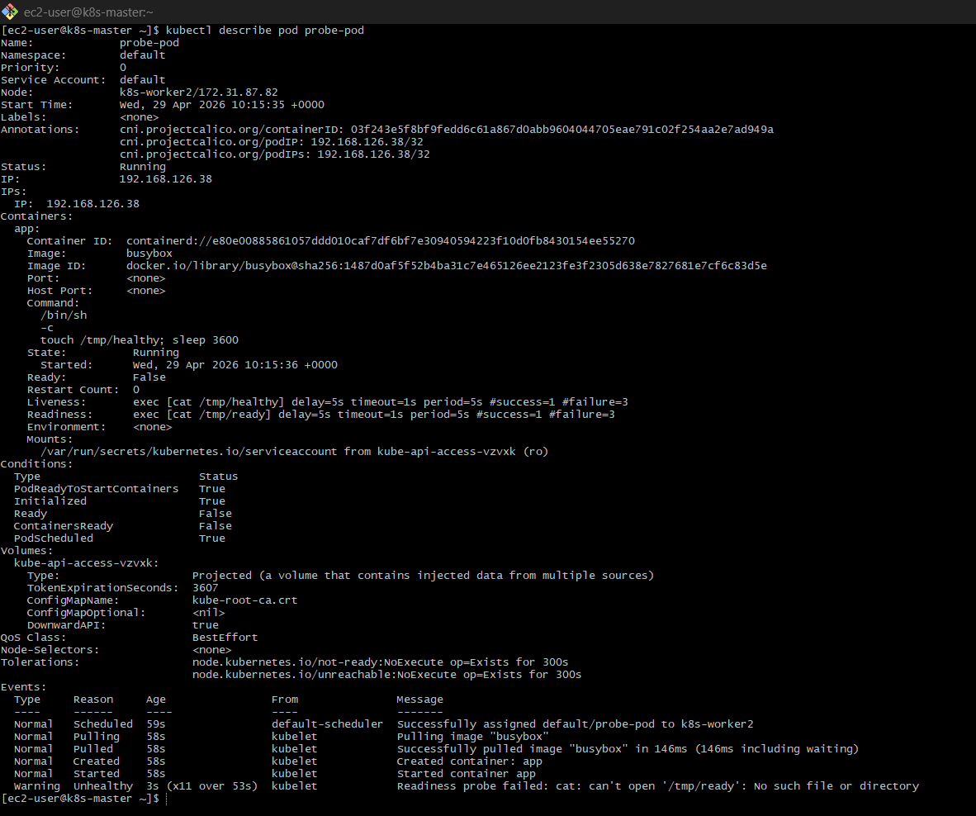

Step 4: Fix readiness manually
kubectl exec -it probe-pod – sh
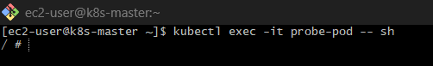
Inside:
touch /tmp/ready
exit
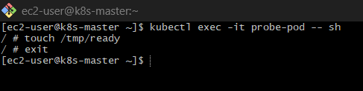

✅ Now check
kubectl get pods
👉 Now:
probe-pod 1/1 Running ✅
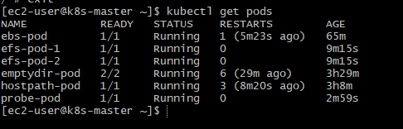

Step 5: Test Liveness (force restart)
Enter pod:
kubectl exec -it probe-pod – sh
Delete liveness file:
rm /tmp/healthy
exit
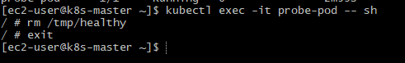

Watch pod
kubectl get pods -w

👉 You’ll see:
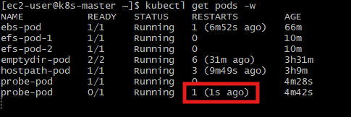
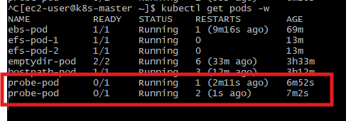

RESTARTS increases
👉 Because:
- Liveness failed
- Kubernetes restarted container

Important Behavior
🔹 Liveness
- Failure → container restarted
🔹 Readiness
- Failure → removed from service traffic
- Pod still running

Real-world example
Use case | Probe
App crashed | Liveness
DB not connected yet | Readiness
Startup delay | StartupProbe

Final understanding
Probe | Automatic? |  | Why
Liveness | ✅ Yes |  | file created in command
Readiness | ❌ No |  | file not created

Bonus: HTTP Probe (used in real apps)
livenessProbe:
httpGet:
path: /health
port: 8080

